|  |
| --- |
| **Policy/Document:** Effective Behaviour Management Policy |
|  |
| **Date approved: January 2020** |
| **Changes made:**  **January 2023 –** p9 and p10 revised, Appendix 6 added and 7-10 deleted  **July 2024 –** Reviewed in light of 2 Year old provision  **December 2024 –** included visual restorative approach p11, altered sanctions and rewards p5-6, Added “referrals” to section on consequences/actions p9  **January 2025 –** Amended table on P.9 |

**1.1 Behaviour Policy Statement**

In order for all to achieve their potential we are committed to creating an environment where exemplary behaviour is at the heart of productive learning, thus enabling all to feel secure and respected. ***We do this by having clear and simple rules which are explicitly taught and modelled by all members of our school community.*** Everyone is expected to maintain the highest standards of personal conduct, to accept responsibility for their behaviour and encourage others to do the same.

We do recognise that for some children following our behaviour expectations are beyond their stage of development. These children will have bespoke behaviour plans which will include personalized rewards to encourage and foster positive behaviour.

The principles central to our core beliefs are based on the work of Paul Dix and his book: ***When the Adults Change, Everything Changes***.

*‘’When people talk about behaviour, they obsessively search for the instant solution. Some peddle magic dust or ‘behaviour systems’ that glisten yet quickly fade. Others relentlessly scream for a bigger stick to beat students down with. Both extremes harbour an irresistible idea that there is a short cut to changing behaviour. They sell the lie that you can provoke sustained behavioural change in others without doing much hard work yourself. The truth is that there is no alternative to the hard work: building relationships with those who would rather not, resetting expectations with those who trample them, being relentlessly positive and sustaining a poker face when confronted with challenging behaviour.’’*

**1.2 Purpose of the policy**

The purpose of this policy is to outline the underlying philosophy that is central to our core beliefs, alongside the provision of a set of precise, practical and agreed set of procedures for our whole school community to work within. The fair and consistent application of our policy is the responsibility of everyone. There are 5 pillars of pivotal practice, these are:

* Consistent, calm adult behaviour
* First attention to best conduct
* Relentless routines
* Scripting difficult interventions
* Restorative follow up

**We praise in public and reprimand in private. Always.**

**1.3 Our Core Beliefs of Behaviour Management (The how)**

1. *Being Inclusive*

* Some of our children, for some or all of the time, will need more of our attention and support than others.
* We have a responsibility to teach social behaviour to all children.
* We should be clear with staff, pupils, parents, governors about which expectations are non-negotiable.
* All pupils have the right to be educated no matter how challenging their behaviour.
* Dealing with challenging behaviour often helps us to find ways to improve our systems, processes and procedures. We should seek to adapt these to fit our diverse population.

1. *Being Positive*

* Behaviour can change.
* Every child can be successful in our school
* We should have high expectations of what is acceptable behaviour in our school and within the wider community and should seek to raise those expectations in partnership with staff, governors with pupils and parents/carers.
* **If we want our pupils to behave in a particular way, we as adults, are responsible for making it clear to them how we want them to behave.**
* We should recognise acceptable behaviour through positive reinforcement – this increases self-esteem
* We should provide pupils with honest and sensitive feedback on their own learning and behaviour.
* Targeted praise is more likely to change behaviour than a blame and punishment culture.

1. *Being Assertive*

* We believe we all have rights - teachers have the right to teach, pupils have the right to learn.
* Pupils and staff have the right to feel safe in school.
* Parents have the right to feel welcome and to know their children work, play and learn in a friendly, safe and helpful school.
* We should never tolerate violent, abusive or anti-social behaviour in the classroom or anywhere in school.
* Staff will require support from each other and outside agencies in order to support individual pupils through learning and making changes in behaviour – regardless of how experienced they are

**1.4 Aim of the Behaviour Policy (The what)**

* To create a culture where excellent behaviour is expected: for learning and for life
* To foster a culture of belonging for all children and adults
* To ensure that all learners are treated fairly, shown respect and to promote good relationships.
* Model the specific behaviour and social skills that we expect to see, e.g. sharing, good listening, showing consideration and politeness.
* Create a school culture which values kindness, empathy and excellent behaviour.
* To refuse to give learners attention and importance for poor conduct
* To help learners take control over their behaviour and be responsible for the consequences of it.
* Involve our whole school community in agreeing boundaries of behaviour.
* Teach strategies for children to solve conflict verbally and peacefully.
* Catch children ‘doing the right thing’ to encourage role models and make expectations clear for all.
* To build a community which is underpinned by our school Values.
* **To ensure that excellent behaviour is a minimum expectation for all.**

**1.5 Our School Rules**

Everyone in the school has rights and responsibilities. To help protect our rights and to encourage responsibility, we have basic rules for our school. The School Rules form the basis of whole school and classroom rules and are a vital part of setting clear expectations throughout the school (these rules need to be used to shape the classroom rules, expanded but not changed, at the start of the school year). Sanctions and rewards apply to racist, homophobic, biphobic and transphobic bullying and language.

**It is important that these rules are discussed and referred to as part of all behaviour management strategies.**

**Be Ready** – being ready to learn

**Be Safe** – being safe around the school

**Be Respectful** – being respectful to all

**1.6 Responsibilities and expectations – our non-negotiables**

**All staff must:**

* Take time to welcome students at the start of the day.
* Routinely refer to ‘Ready, Respectful, Safe’.
* Model whole school visible consistencies – the Belle Vue Way
* Embed agreed routines in their classrooms.
* Never ignore students who are failing to meet expectations.
* Always redirect students by referring to our agreed rules.
* Be calm and allow children ‘take up time’.

**The Senior Leadership Team will endevour to:**

* Be a visible presence around school throughout the day.
* Ensure any staff training needs identified and targeted.
* Use behaviour data (CPOMS/Scholar etc) to assess impact and to target and monitor support.
* Encourage use of positive praise; phone calls/postcards – for children who have received at least 5 positive points within 5 school days.
* Celebrate those students whose efforts go above and beyond expectations.
* Regularly review provision for students with a range of needs.

**Members of staff who manage behaviour well:**

* Deliberately and persistently ‘catch’ children doing the right thing and publicly praise
* Develop positive relationships with all students
* Work relentlessly to build mutual respect
* *Demonstrate unconditional care, kindness and compassion – being relentlessly positive*
* Remain calm and keep their emotion for when it is most appreciated
* Remember to praise in public and reprimand in private without raised voices

**Students need teachers to:**

* Allow them a ‘fresh start’ every lesson
* Help them to learn
* Be fair and be consistent
* Have a sense of humour

Whilst all negative behaviour should not be ignored there may be times that it is really inconvenient to deal with it i.e. you’re on the way to the loo, or you really need to be somewhere else. You may need to extricate yourselves from the situation yet still deal with it – “I need to walk away now, you know the rule about talking to adults. Thank you for listening”**.** It is critical that staff will stop, notice, remind and move on.

These are the visible behaviours that children will expect to see staff exhibit consistently. At all times, staff should be calm and consistent to establish respectful relationships with our pupils. **All adults in school will avoid shouting at children or becoming emotionally charged**. Our aim is to pay first attention to the absolute best conduct to establish clear expectation for behaviours for all children.

***Remember: All behaviour is communication.***

**1.7 Consistency in Practice**

A consistent approach in the application of our three simple rules is simply essential. We aim to be consistent in every aspect of our curriculum delivery and so the same applies to our implementation of our agreed rules for behaviour. We aim to demonstrate:

* Consistent language with consistent response to students that is simple, clear and concise.
* Consistent follow up: teachers taking the lead and ensuring certainty for pupils during behaviour interventions.
* Consistent positive reinforcement through routine systems for reinforcing, encouraging and celebrating expected behaviour.
* Consistent, clearly defined consequences that are applied by all staff within classrooms.
* Consistent use of our agreed visual cues (instruction loaded countdowns, raised hand for quiet, eyes on me, show me that you’re ready) so that children are not second-guessing expectations of different teachers.
* Consistent modelling of emotional control; teachers as role models who reflect and learn.
* Consistent routines and expectations for behaviour across the whole school site.
* Consistent environment in which our visual messages echo and reinforce our core values.

**1.8 Safeguarding all of our Pupils**

Most children, at some time during their time at school, will require extra support in managing their behaviour. At these times the behaviour strategy may need to be adapted to support vulnerable pupils. We address the underlying factors which may have contributed toward the difficulties as school. These may include:

* Trauma/Loss
* Relational/attachment difficulties
* Poor emotional literacy skills
* Negative thought patterns
* Negative view of school
* Low self esteem
* Lack of self-efficacy
* Poor social skills
* Social communication difficulties
* Friendship difficulties
* Weaknesses/gaps in basic skills
* Specific learning difficulties
* Speech and language difficulties
* Neurodevelopmental difficulties
* Lack of awareness of boundaries
* Attention difficulties
* Controlling needs

**Children’s behaviour is often linked to outside influences.** A noticeable change in behaviour or consistently challenging behaviour needs to be reported to the DSL to address/ascertain any safeguarding concerns that may arise – **this needs to be done in accordance with our safeguarding practices.**

**1.9 Positive Reinforcement, Responsibility and Reward**

At Belle Vue Primary & Nursery School excellent conduct is valued, appreciated and recognised.

Our rewards include:

* verbal praise
* positive recognition
* additional responsibilities
* positive notes
* certificates
* positive phone calls home
* positive post cards home
* positive referrals to other members of the school team
* acknowledgment on class recognition board.

**Other approaches:**

1. **Celebration Assembly**

Celebration Assembly is held each week (whole school), usually on a Friday, to share our successes.

Awards include:

* **Presentation Award** – Pupils having pride in their work, improving their presentation or having amazing presentation
* **Attendance** – class with the highest attendance. Tracked each ½ term with the class with the highest attendance getting extra break time.
* **Birthdays** – stickers
* **Team points announcement**
* **Belle Vue Way Ambassadors -** Weekly award for following our Belle Vue Way consistently
* **Parent praise Assembly** – Parents of children identified invited – this will take place at the end of each half term
* **Hot Chocolate celebration every 3 weeks** – 1 per class – someone that goes above and beyond. Demonstrates that they follow school rules consistently for 3 weeks
* **Sport participation award** – 1 from each class to be given out during the PE lesson
* **Termly attendance badges** – 97%-100%

**Team Points**

Each child is allocated to one of four teams. Team points are awarded for quality of work, displaying a strong work ethic, their contribution during the lesson. Team points should be displayed in class, they are counted each week by Team Captains and the winning team is announced in celebration assembly. At the end of a half term the winning team gets a “top team treat’. Children receive a Bronze, Silver, Gold or Platinum award once they have reached a set number of team points (25, 50, 75 and 100).

1. **Recognition Board**

The Recognition Board, when used effectively, is a good visual tool to reinforce positive behaviour. **It is not used to reward academic achievement etc. (team points are used for this).** Each classroom will have a Recognition Board with space to put children’s name on. Alongside this board will be specific targets that the class is working on. If a child is seen demonstrating they have achieved the target, they are recognised by having their name put on the board. See appendix 3.

1. **Positive referral**

Positive referral’s can be inputted onto Scholar Pack. These will be looked at collectively over a half term and recognition given – Phone call home by class teacher/SLT

**2.0 Strategies for dealing with inappropriate behaviour**

There are a number of strategies that a teacher can use for the normal day to day behaviour problems that can exist in any class. **Teachers should ensure that sanctions protect the pupils self-esteem and maintain a healthy relationship between pupil and adult.** In addition, as a school we recognise the unique nature of the personal, social and emotional needs of our youngest children in EYFS. Staff will tailor the strategies to the needs and level of understanding of these children whilst at all times adhering to the guidelines outlined in this policy.

When instances arise when behaviour is unacceptable, we have an agreed pathway to managing conversations and interventions around those situations. For the vast majority of our children, a gentle reminder is often all that is needed to get back on track and to resolve most situations. However, when this does not work, we follow a clear, consistent and planned pathway to achieve a resolution (See Appendix 1). **We understand that a common and consistent use of language around behaviour is key to creating clear boundaries for learning how to behave. We acknowledge that phrases such as ‘kicked off’ or ‘screaming fit’ are unhelpful in these moments. Conversations around behaviour should remain calm and professional. Any information that needs passing on regarding the behaviour or conduct of the child should not be done in front of the child or the rest of the class if another member of staff is called to support. Information should be shared sensitively with children being spoken to and not about when dealing with unacceptable behaviour.**

**All conversations around behaviour in the classroom should be conducted, in the first instance, by the class teacher.** It should always be made clear that it is the **behaviour that is unacceptable and not be made personal to the child – phrases such as naughty boy/girl are not to be used – it is imperative that we remember, it is the behaviour that is unacceptable and not the child**. If a situation is resolved, the incident is recorded at the earliest possible opportunity on either Scholar or CPOMs. We have a comprehensive system for recording behaviour incidents using an agreed criteria. It is important that incidents are recorded as soon as possible as all are date stamped. Continuous inappropriate behaviour and/or serious incidents will be addressed by SLT.

**Always give take-up time for children to respond and process the instruction.**

Our Pathway

* Redirection
* Reminder
* Caution
* Calm Time - Space to cool off/calming time - In the classroom - in the parallel class - in a designated space
* Follow up restorative conversation

**2.1 Very serious Incidents**

If a child demonstrates danger to themselves or others, SLT should be notified immediately by the class teacher or TA phoning. Should SLT not be available, the class teacher/TA will ring through to the admin team and they will find a member of SLT.

Depending on the age of the pupil, ‘serious’ or repetitive ongoing incidents of the same nature will be dealt with at the discretion of SLT. All serious behaviour incidents must be reported immediately to SLT. Staff will be asked to record full details on CPOMs as soon as possible after the incident but not during teaching time. Unacceptable behaviours must not be managed through our system of stepped sanctions but referred to a member of SLT.

Such incidents may include:

* Fighting
* All forms of bullying
* Racist, sexist or homophobic comments
* Repeated defiance/rudeness
* Using abusive/offensive language
* Violence against other pupils or adults

There is a range of consequences for these actions, including short time-out away from the class, meetings with parents, internal and external suspension and ultimately permanent exclusion. See Further Sanctions 2.3

When dealing with an episode of extreme behaviour, a child may need to be guided to an area away from the incident/class and where possible by trained staff. Our trained staff are Mrs C Davies, Deputy Headteacher and Mrs S Richardson, Assistant Headteacher. Please go to section 2.6 for more information.

When traumatised, some children portray extreme behaviour and they may require a calm adult to be the 'thinking brain', as their 'emotional brain' will have taken over their thinking brain. Staff will use their discretion and support each child depending upon their individual needs. In circumstances such as these, rather than providing a child with ‘time out’, they will be offered ‘time in’ whereby an adult will provide the emotional support the child requires. Additionally, some pupils require ‘distraction’ techniques or may simply need to ‘let of steam’. This may be in the form of spending several minutes taking part in a physical activity to allow the child to self-regulate.

**In the case of a serious incident within the EYFS the member of staff will be supported by another member of staff from the EYFS team. Further support from SLT will be obtained if needed.**

**Responding to inappropriate behaviour**

|  |  |  |
| --- | --- | --- |
| **Low level incidents to be dealt with by school staff, not SLT**  Not following the Belle Vue rules or Not following the Belle Vue Way | **Incidents to be dealt with by class teachers:**   * Repeated defiance/rudeness * Swearing * Racist, sexist or homophobic comments (always reported on CPoms) * Inappropriate use of IT within school – always reported on CPoms | **Serious incident – deliberate with intent**   * Physical Fighting (deliberate with intent) * All forms of bullying – consistent and persistent * Violence against other pupils or adults * Persistent, repeated racist, sexist or homophobic comments * Peer on peer abuse * Sexual violence/harassment |
| Low level one off | Low level repeated | Serious incident |
| **You might:**  Use non-verbal cues to avoid disruption to flow  Express private, firm disapproval  Restorative conversations using the visual prompts  Reaffirm expectations for behaviour  Use of Recognition Board  Allow take up time to let the child save face, to process your instruction or to avoid confrontation in front of an audience  Record on Scholar – SLT to monitor patterns – may request class teacher to call parent/carer | **You might:**  Give a time out within the classroom/move their seat/or if necessary time in an alternative classroom.  Give a closed choice: You can either get on with your work now or you can finish it in your own time.  Keep them back briefly at break/lunch to reset expectations with use of visual cue cards  **Class teacher** to speak to parents this can be via phone call or face to face at pick up/drop off or through a specifically arranged meeting. This form of communication should be recorded on Scholar using the ‘confidential’ tab.  In circumstances where you require an additional adult, please ask your year group partner to support  If further or regular communication is agreed with parents, emails (via info@ address) or phone calls can be made.  Record on Scholar Pack – Referral – Patterns noted by SLT, children to be seen during Friday assembly by SLT. | **You will:**  Ensure that everyone is safe and send for SLT. Where possible, member of staff to remove the child/children from the situation and call for a member of SLT.  **Senior Leaders will:**   * Remove the child from the classroom/playground – if necessary. * Ascertain details of the incident first from the member of staff and then from the pupils involved. Where applicable, CCTV footage will be viewed. * Make decision on form of consequence/sanction. * Set an internal exclusion if appropriate. * Issue a suspension or permanent exclusion if appropriate * Contact parents to inform them. * Expectations will be re-set when appropriate e.g. if a pupil receives a fixed-term suspension, expectations set during reintegration meeting. * If deemed necessary, and likely to support the child in moving forward, place the child on report for two weeks (child checks in with teacher - this will be to monitor behaviour both in class and outside).   Record on CPOMS – Member of staff who has witnessed the incident/called for support must record it and record the action taken. SLT will add any further actions. |
| **Reasonable adjustments - for age, stage and development.**  **Where a child has a mental health condition (ACE/significant change in environment) that amount to a disability and this adversely affects their behaviour, we make reasonable adjustments to our policies, the physical environment, the support we offer and how we respond to particular situations** | | |

Restorative Widgets – can be printed off and put on a lanyard.

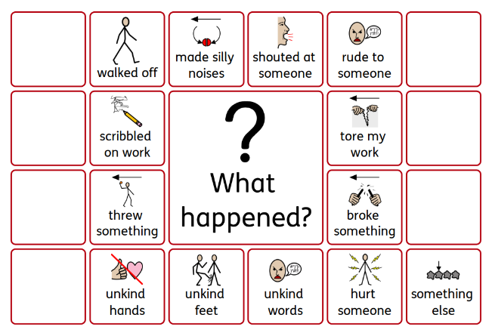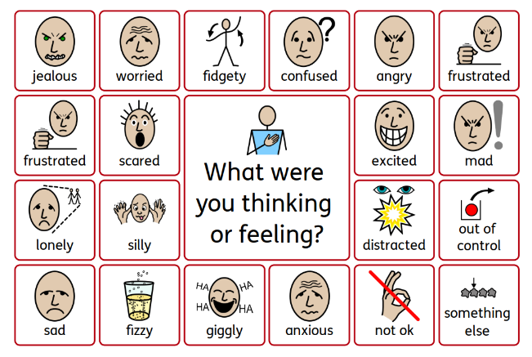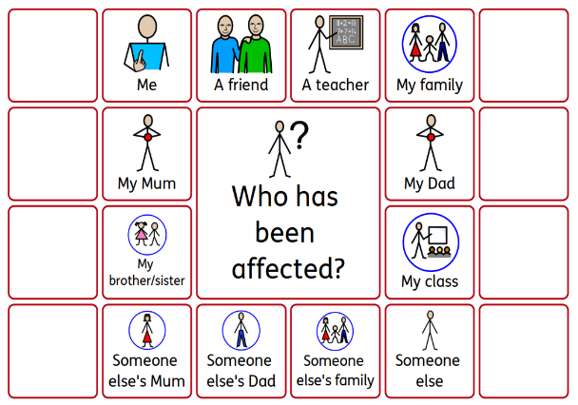

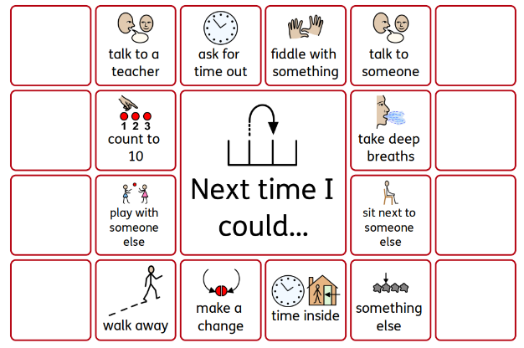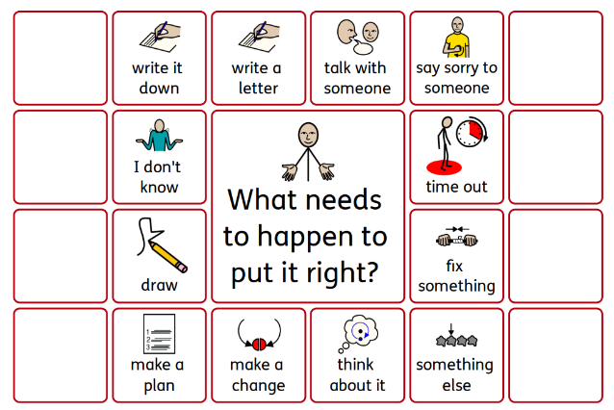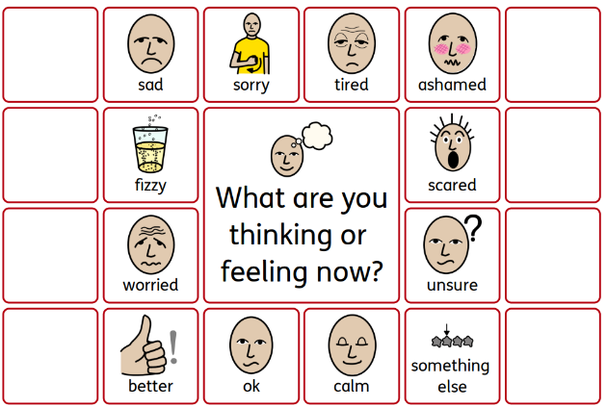

**2.2 Crisis intervention**

In accordance with our Crisis Intervention Scripts we will always:

* keep language to a minimum
* keep it concise, clear, calm and kind
* remain firm, fair and caring

Key Adult responses:

* Attune – communicate an understanding of the child’s emotion. Meet the angry energy with loud empathy
* Validate – Help find the connection between feeling and words. Affirm and recognise what the child is feeling
* Contain – be psychologically strong, kind and calm enough to be able to stay with the child’s emotions.
* Soothe – Calming activities to enable thinking to happen. Calm tone and touch

**Every attempt must be made to use the de-escalation scripts/ before another member of staff is called.**

# Further Strategies

There may come a time when the teacher feels that the usual sanctions are proving ineffective and more serious measures are required. The key issue is to work in partnership with the pupil’s parents/carers to find ways to best support the pupil.

Parents/carers will be contacted by the School to explain the nature of the incident and a record of the discussion will be kept on file. The focus of the discussion will be what needs to be done to improve the current situation. A Behaviour Plan will then be compiled with the pupil and the parents/carers, detailing the consequence for each bad choice as well as rewards for good choices.

The Behaviour Plan might refer to:

* Individual Behaviour Targets – shared with the class and celebrated with class rewards when they are achieved;
* Exclusion from clubs and trips where a risk assessment deems it unsafe for the pupil to attend.

The child’s behaviour will be monitored over further weeks for improvement.

**2.4 Additional Behaviour Interventions**

For certain children placed on the SEN register for social, emotional & mental health (SEMH) staff will monitor their behaviour. Teaching staff will consult with the SENCO, who may discuss with SLT, behaviour targets for each child. The child will meet weekly with a named adult to analyse progress, discuss strategies to improve behaviour and set new targets. Progress will be shared with parents, staff and the SLT.

At an agreed review it will be decided whether outside support is required.

The school may refer to outside agencies for additional support for a child who repeatedly doesn’t meet our behavioural expectations.

**However, it must be recognised that changing behaviour takes time and can only be achieved in a context of good, vibrant teaching with the school, outside agencies and home working together.**

# 2.5 Exclusion and Suspension

Unfortunately, there may be rare occasions when the Headteacher must consider whether it is appropriate to exclude a pupil either for a fixed-term (Suspension) or permanently. Should this be the case then the School and Governing Body will follow statutory guidance from the Department for Education, contained within the publication “*Improving Behaviour and Attendance: Guidance on Exclusion from Schools and Pupil Referral Units*”. This can be found at:

<https://www.gov.uk/government/publications/school-exclusion>

Following a suspension, the pupil and parents will meet with a senior member of staff, usually the Headteacher or Deputy Headteacher to discuss reintegration into school and the best way forward to support the child.

# 2.6 Physical Restraint of Pupils

Both the Department of Health and Department for Education acknowledge and accept that some children and young people experience difficulty in acquiring self-mastery and will require additional help to achieve this important developmental task, and that on occasions this will include the use of physical intervention. The DoH Volume 4 and the DfE Circular 10/98 make explicit the circumstances in which it is permissible to use such strategies and which people are authorised to do so.

There are five circumstances in which children can be restrained:

* If they are about to commit a crime
* If they are about to injure themselves
* If they are about to injure a member of staff
* If they are about to injure another pupil
* If they are causing damage to the school

However, the emphasis is on the question of reasonableness. Reasonableness is enough force to stop whatever was about to happen from happening.

At Belle-Vue identified staff have been trained in using the CPI Safety Intervention approach, the pupil will be encouraged to calm down before being appropriately guided to a safe area to continue calming down – Headteacher’s office or a room that is quiet and available. The child will be returned to class only if a guarantee can be made by the pupil that s/he is able to do so voluntarily. Parents will be informed of the actions taken by School.

The DoH Volume 4 and the DfE Circular 10/98 also refer to issues of recording and reporting of such incidents. At Belle Vue Primary & Nursery School the CPI record book will be completed (Bound and numbered book) and parents will be informed.

# 2.7 Monitoring of Behaviour

At Belle Vue we believe it is important to monitor behaviour. This helps us to identify trends and patterns and gives us data with which to speak to parents/carers and governors.

Class teachers will use ScholarPack to record and identify patterns in behaviour. This is monitored by the designated member of SLT who monitors behaviour.

Exclusions and Suspensions will be monitored by the Governing Body and Dudley Local Authority.

**2.8 Pupil’s conduct outside school**

Teachers have a statutory power to discipline pupils for misbehaving outside of the school premises. Section 89(5) of the Education and Inspections Act 2006 gives Headteachers a specific statutory power to regulate pupils’ behaviour in these circumstances. Subject to the school’s behaviour policy, the teacher may discipline a pupil for any misbehaviour when the child is:

* Taking part in any school-organised or school related activity
* Travelling to or from school
* Wearing school uniform
* In some other way identifiable as a pupil at the school
* Online activities, including cyber bullying

Or misbehaviour at any time, whether or not the conditions above apply, that:

* Could have repercussions for the orderly running of the school
* Pose a threat to another pupil or member of the public
* Could adversely affect the reputation of the school

**2.9 Application of the Policy**

This policy is applicable to our entire school community. If it is to be effective everyone must use it with confidence and consistency. There may be occasions when adaptations need to be applied, e.g. swimming lessons, in the dinner hall, at playtimes and when off site, etc., but the same principles of promoting good behaviour will always apply.

**3.0 Monitoring & Evaluation**

The SLT will review and monitor the effectiveness of the policy and report to the governing body at least once a year. Using ScholarPack, incidents will be monitored weekly with interventions put into place following team discussions and input from staff. SLT will monitor the use of language around behaviour, visible consistencies and relentless routines throughout school, with records being kept noting any changes/updates to the policy.

**Appendix 1:**

**Behaviour Pathway**

All learners must be given “take up time” in between steps. Please note, steps should never be missed or accelerated even when dealing with repeated low-level disruption

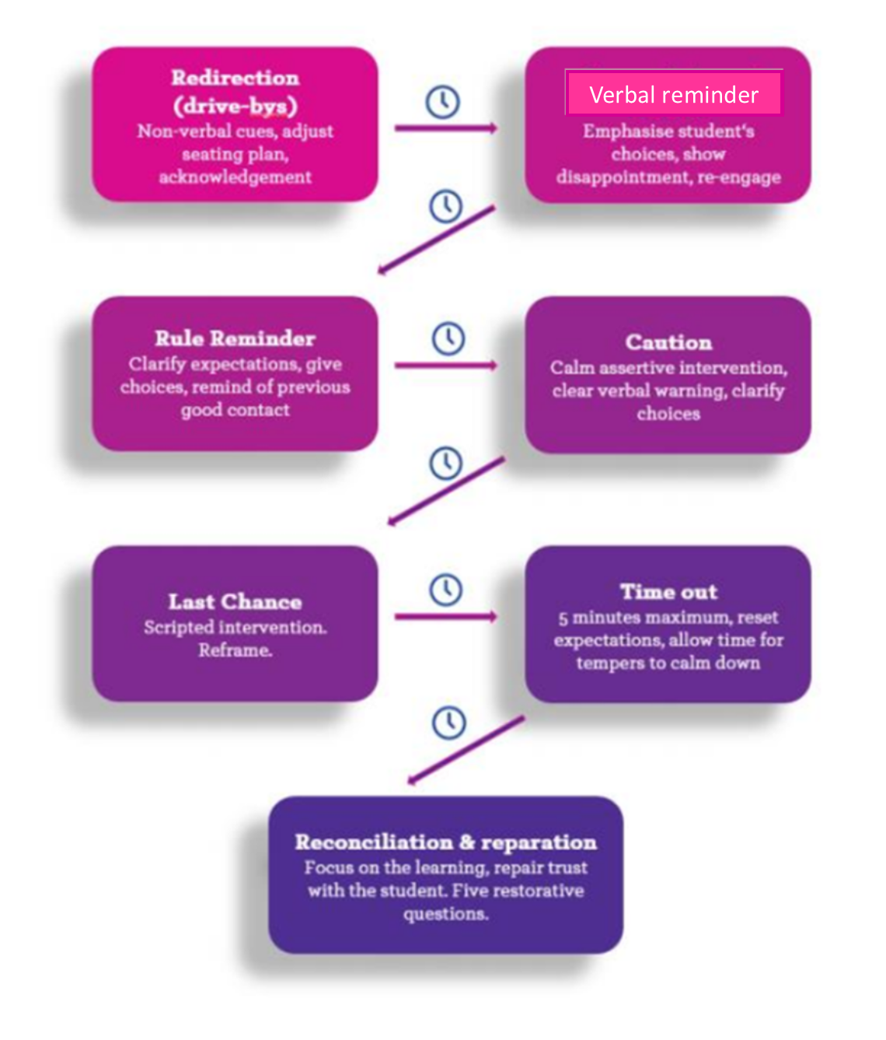

# Appendix 2:

# Classroom Management and Organisation

Good classroom management and organisation should create and sustain a positive and secure environment in which pupils can think and learn effectively, and so be less inclined towards unacceptable behaviour.

**In the Classroom**

A good classroom is clean, tidy and stimulating and is arranged:

* to assist easy movement around the room;
* to give visual access to focal points;
* to allow individuals to have their own space;
* to show due regard to pupils with visual, audio or physical disabilities;
* to display a good standard of pupils’ work.

**Management Skills**

Pupils should be encouraged to share responsibility for their classroom and a set of rules and routines should be negotiated at the beginning of the academic year and followed. **The example that the teacher sets should not be underestimated.** High expectations of acceptable behaviour and peer relationships should be evident and will help to foster an atmosphere of mutual respect and understanding. Within the vast range of aspects of classroom management, three key factors need to be noted: calmness, clarity and consistency.

Calmness

* Avoid confrontation
* Avoid shouting
* Try not to over-react
* Listen
* Use sanctions sparingly
* Sustain a balance between hard work and relaxation

Clarity

* Lesson planning is clear and effectively differentiated
* Learning intentions are made clear to pupils
* Delivery is interesting and enthusiastic
* Good question and answering techniques are used

Consistency

* In rewarding both good behaviour and good work
* In response to unacceptable behaviour
* In response to lack of effort
* In expectations of work and behaviour
* In marking work
* In applying school rules
* In maintaining a positive, supportive and secure environment

**Avoiding Conflict in the Classroom**

* All classes must ideally have a seating plan – the children know where they are sitting. In EYFS children must know the key expectations for each area they are working in.
* Keep calm, avoid shouting and becoming over-excited
* Maintain a confident outlook and praise the positive
* Be consistently fair
* Maintain control through mobility, attention to individuals and eye-contact
* Keep a balance between hard work and relaxation. Use appropriate humour when appropriate.
* Know the pupils
* Do not punish personality but behaviour
* Avoid using sarcasm
* Avoid blanket punishments
* Negotiate standards of behaviour through group discussion
* Show a genuine interest in the individual and always be prepared to listen
* Talk to a potential child struggling to manage behaviour privately – try to avoid public discussion
* If a class is restless, consider changing the activity, place or groupings
* Try to identify the cause of a situation to help you clarify the problem
* If contracts are set up, make sure the targets are achievable
* Keep a record of observed behaviours and avoid “woolly” statements
* Provide a time and place for cooling off

# Appendix 3:

**Use of class Recognition Board**

Class Recognition boards are a visual way of recognising children who are achieving behaviour targets.

* Behaviour targets should be achievable, reviewed often and should exemplify this behaviour policy.
* Staff have the freedom to design their own Recognition Board – however they must have space to display all of the pupils’ names and they must have space to display the behaviour targets.
* When a child is recognised for achieving the target their name is moved on to the recognition board.
* There should be no more than two behaviour targets at a time.
* Support is there for all teachers in setting this system up and maintaining it.
* Boards could need to be refreshed every lesson, or when needed
* If a child stops displaying the asked/recognised behaviour – the pathway should be followed. Children shouldn’t have their names removed.

Examples:

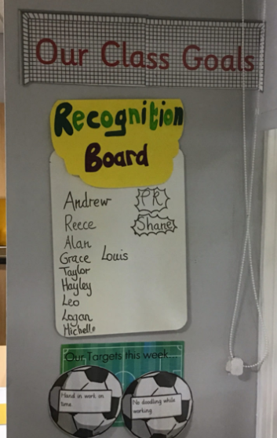

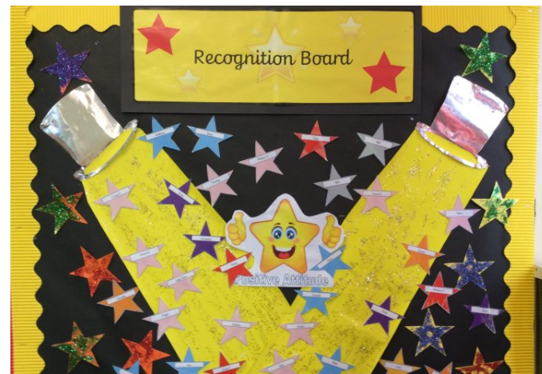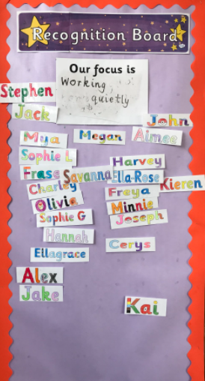

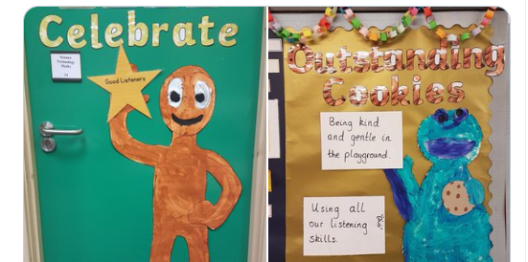

**Appendix 4:**

**Child friendly version of behaviour management**

If things go wrong in class and you haven’t made the right behaviour choices we will help you to put it right.

1. A behaviour reminder will be given. For example: “Joe, I can see you’re off task and not listening. Do you need any help?”
2. A second behaviour reminder will be given. For example: Your teacher will come and speak just to you. They might remind you of our school rules and ask you to follow them. This might happen more than once. They will notice if your behaviour changes for the better.
3. A firmer behaviour reminder will then be given. Your teacher will speak to you calmly and privately and remind you of our expectations. They will tell you what will happen if the behaviour continues.
4. If your behaviour doesn’t change you teacher will give you time out to calm/reflect. This will usually be in classroom or if we feel it will help you, in your other year group class. This will be for a short time only.
5. When you return from time-out your teacher will talk to you about your behaviour you’ll be welcomed back with a fresh start. It might need a conversation with your parents/carers. If your behaviour hasn’t changed then you might need another time-out or conversation with a senior member of staff.

If there is a serious incident such as:

* Fighting
* All forms of bullying
* Racist, sexist, homophobic comments
* Repeated defiance/rudeness
* Using abusive/offensive language
* Violence against other pupils or adults

A member of the senior leadership team will be called immediately. There could be a range of consequences for these actions, including time-out, phone call home, meetings with parents, internal exclusion where you are kept away from your class in school, external exclusion where you must go home.

**Rewards for good behaviour**

Our rewards include:

* verbal praise
* positive recognition
* additional responsibilities
* positive notes
* certificates
* positive phone calls home
* positive post cards home
* positive referrals to other members of the school team
* acknowledgment on class recognition board.

**Appendix 5:**

**Why the Restorative approach**

**Definition**

The aim of restorative practices is to develop community and to manage conflict and tensions by repairing harm and building relationships.

**Restorative Practices in Schools is about:**

* building safer schools
* changing behaviour not punishing
* adults modelling restorative approaches
* finding ways to repair harm
* supporting staff, children and families to use RP to build community

**Why use a restorative approach?**

* Punishment doesn’t meet needs of those who suffered
* May be kudos or ‘street cred’ attached to the punishment
* Offenders don’t have to face full effects of actions
* Offender may feel isolated and it may be difficult for them to get back into school community, making rule-breaking more attractive
* If problem behaviour persists, child may be pushed down a road of exclusion and marginalisation. They may be removed from school, but remain a problem in the wider community

**Restorative Questions 1**

To respond to challenging behaviour:

* What happened?
* What were you thinking about at the time?
* What have your thoughts been since?
* Who has been affected by what you did?
* In what way have they been affected?
* What do you think you need to do to make things right?

**Restorative Questions 2**

To help those harmed by others’ actions:

* What did you think when you realised what had happened?
* What have your thoughts been since?
* How has this affected you and others?
* What had been the hardest thing for you?
* What do you need to do to make things right?

**Appendix 6:**

**How to…**

**What behaviours do we want to be the norm?**

|  |  |  |
| --- | --- | --- |
| https://lh4.googleusercontent.com/LuUH8HpoKh6WjszjstUpnTLGLXNTVJd-Wld5UCu_hqlSjZXLea2IOqMYmZVvBsy_CSy11dDz3VVGrTdHdzqfoiKaGsH2GmJ3-KyPr1cUcnWcdbkIVbfdqYPcvoK7n46FOX4OeDvANex2bZxTY3bTI1ft8dx9uL7ZH3Y3Hw2dbStLHAGc1E1_bp0diJ4yxr47BHNYDZvsVQ  **Ready** | https://lh5.googleusercontent.com/dLFatkIY68lcGbkd4l8oD2JW5vJLcMZ2Gye92-yASUSS40-6yeDLpP6QChLS5O1h0RElAqc_idgXat2PQbeFgtu-HM5iyb3s5AMWguqUSkuoz9nx6VwYZm1x7n5ccg8Aq7xPnOAbwK7aK52umwEqQlX2YKE2Cl83ybg4eoXTGSuGxIAn1MkV1131kKpukGokLOEE8ym6uQ  **Respectful** | https://lh3.googleusercontent.com/qQO_QyKqyFHCTdoLvYh7OSR0rsxireQeeDt1zKu7Ois8s3jJL1ckjTagaiAiADGRYVlI1YHcaokVBz_04DGFxyZ7LuZpXQ1c2JuPjB1_SkXhZJyWo9Pb6mc2iWYyoVOUTcOvmmPaWig9QrAiVyvk2ou7fHt8GU5Gxf7RabOaD45hxtqyRIiwNOreoqBN7NuyBR8J_tsJpg  **Safe** |
| * Come to school on time * Listening to learn * Follow instructions the first time of asking * Start work straight away * Wear the correct uniform * Line up promptly * Come to school with the correct equipment | * Greet each other politely when we arrive each morning * Pick up after ourselves and others * Do things for others because it feels good * Work hard in lessons * Notice when others have done something for me. * Hold doors open * Win and lose gracefully | * Move calmly around the school and outside – tremendous transitions – legendary lines – wonderful walking* * Use play equipment properly * Kind words, hands and feet * Tell an adult if something is wrong * Play only in the places allowed * Use technology responsibly * Wash hands regularly * Catch and bin coughs and sneezes. |

**Setting and maintain social norms**

|  |  |  |
| --- | --- | --- |
| What to do: | | What to say: |
| Explain **clearly** what you expect, provide examples and **model** it.  **Tell them why** good behaviour is important and **get them to explain** it to each other and the group.  Narrate **positive recognition** for children doing the right thing.  Frame instructions using **positive** **language**.  Gain attention, **pause**, then give an instruction.  **Only talk** when the group is **silent** and looking at you.  Have a **signal for silence** such as a bell. | **Stand still** to speak and give good **eye contact**.  Explain **expectations before** they follow an instruction.  Break expectations into **small chunks** and provide lots of practice.  Arrange furniture with a **clear purpose**.  Have a **lining up order** and instruct line leaders to **stop** at given points.  Keep expectations at all times – **don’t ease off**.  **Reboot** expectations regularly. | **Avoid asking ‘why’** questions when dealing with misbehaviour.  Use **partial agreement (maybe, but)** to stop conversations going off on a tangent.  **Draw attention to the majority** meeting expectations rather than the minority not doing so.  Give **conditional permission** when children ask to do something *When you have started your work, then I can come over and help you.*  **Narrate the reason** for tidying up: *If we leave this room like this, someone will have to stay later and see their families later.  That isn’t right.  Let’s do this together now…*  **Narrate the reason** for not wasting food: *It has taken three hours to cook the food and putting it in the bin is not right.  Eat all you take.* |

**Creating a feeling of belonging**

“If we do not show children that they belong in our community, they will find somewhere else to belong.” <https://neu.org.uk/media/13026/view>

|  |  |  |
| --- | --- | --- |
| Narratives | Teaching social skills | Setting tasks for children |
| ‘I’m telling you this because **I have very high expectations** and **I know that you can reach them**.’  Highlight **interests** and **experiences** you and children have **in** **common**.  Narrate **how lucky children are** to have adults that **care** about them to hold them to **high standards**.  Tell children **how hard you work** for them preparing lessons etc.  Show **kindness** as the default in **every** situation.  Show a **genuine interest** in children’s lives.  Emphasise the **similarities**, **shared values** and **common identity** between children.  Narrate **what makes Courthouse special** regularly.  Narrate a **child’s value** to the group.  Tell children that **they belong** to the group. | Teach children to **notice** when someone has done something for them.  Encourage **new** **friendships**.  Involve children in **choosing awards** for their peers (such as the recognition board).  Encourage children to **take joy in the success of others** and to appreciate their hard work.  Encourage **humility in success**.  Encourage children to see their **peers’ points of view**. | **Greet each other politely** each morning / first time they see them.  Show **kindness** as the default in **every** situation.  Involve children in **choosing awards** for their peers (such as the recognition board).  Get children to think / write / talk about **values** **important** **to them.**  Develop a **collective activity** e.g. song / dance / game.  Children write termly **thank you letters**. |

**Enabling success so that children are motivated**

|  |  |  |
| --- | --- | --- |
| https://lh5.googleusercontent.com/ZFeNPcezL60chH64BHQtgkDeaJyiLoEbTL9QPC8lnNkUNI5Ajkjxm1oDoI-v9NGPtXipqs_KVBMP_0F_Q6fc_QvdQrgfYu7gsvxg755x2Eq3yobcpLu28XXd76qnuEQjIZp6U3fRtnL85Ejpuy4xT5f7zt02TPxjOUvkKysGsjNRXg-4yELLAa4202F8Hd1oyxGZ9yd2Aw  Motivate the elephant | https://lh5.googleusercontent.com/wikZ45l9jayr1RasOBUBfEb_X_jHa2vIgvL5dq8zfs-NDUH24Ln2gTcD698hefq4YmsIw9LBm1IlvucZvli5vTGRT4bN_Yk9RwzxjTisbWdYC18qSD7lYsAlcPNHfL3dwsRKhwW1bt2ouqV0d1Fyxm2J7JEYFhLmgEqBBzxIClnRe2kirTgu79_-pXi0_mDysqYGwjFXtg  Direct the rider | https://lh5.googleusercontent.com/AZRbFrEGlm8usGXTRp931SLFCZMTZh9bAcBe7i6WAgGB0UtTNDqCIQ0TD0WKiyUCOSFzrcJZE0Z8U-Vc1MfOywBK-Tnqc_UNPgzPZvHDbRbDIlrH5gCE3nArCol8-0q7jsCmfyy2lY_slHrVwZZPv7hAvHSb4xj_mU_oZm1k8VSfSIY1M61mls996HdDypkL5YUNpDdZTw  Shape the path |
| Give positive recognition.  Provide lots of practice.  Explain why the work is important.  Understand that different children are motivated by different things (pleasing adults, wanting to be the best etc.)  Explain that they were successful because of their own efforts.  Make the desired behaviour sound appealing – you’re going to be an excellent role model. | Provide clear explanations and modelling.  Give short, clear instructions (consider pictorial prompts).  Have a clear outcome in mind.  Show an example of what excellence looks like.  Give timely and useful feedback.  Script the critical action: first tuck in your shirt. | Provide scaffolds.  Prevent disruption.  Break tasks into small steps.  Make it easy to start the work (think one click purchasing on Amazon). |

**Recognising Success**

|  |  |  |
| --- | --- | --- |
| We want to encourage more: | | |
| https://lh5.googleusercontent.com/69VDvlgVFwI1ez9Q9tPs-QVBSGTUa7PsTuo6iAaiA8FyQNN-a1jANTL9b4by_U1KubmRSWZWbP2taq0O3C8MbsqpoYr-r3tDalXlCHuxSDCyEYIAQuLS0kSISKrf9-Ifd4BbBUc0kKqdKfzns-XE_GSAtpZhhmuQm-82sSMrfgpU56Ltj2om6JgcpHOuwWV4zSQqo831nQ  Kindness | https://lh4.googleusercontent.com/He0a07Wo2pi0QsGYEeSy_3mroWET5ouzUqgpRDFbZeEVGuSNKGQ4aX-aL_MvjzaaMczvwLMmLGis7qI07TRrKMXF59QNb3i4GouEoYC6_mB0rexuExWycbUIfUnWn_3MSmCAKoPqLZhnGUu1y_2jn6lya_C3ZXGK1JBrjnxI0N72SV4h2J3Onqj8DPzEAYOibRs170xbUQ  High quality work | https://lh5.googleusercontent.com/K0nXAuuObv6b7YOZe1Fc_R555nU8Yc0eYCiE8xivPfB2ATMxhphtMQWglyYiJHxK4QjRQD4npZxDYO4Yp6B_wc3Y6Y8_HWC-_d7LWVN6ZAVtnpgbtWDJ6zh8M0FXAKP29l8qxsPY2Ntvr4AqLWs1C-zJeACDQ7B8tA5g8e-zuZj7sS6t3EjzNnIose_Hf1a2uffEZHglCw  Productive classroom habits |
| **Narrate the story of their success to them and others, focusing on what they could control.** | | |
| team points  tell parents  share success with other staff  award | postcards with class celebration  tell parents  share success with other staff  award | class recognition boards  tell parents  share success with other staff  award |

**Key starting points/Transition mornings**

|  |  |  |
| --- | --- | --- |
| Talk our aims and values | Grow your reputation | Set your expectations clearly |
| Explain our values and how to live them.  Ensure all adults speak to the class and insist on the same high expectations.  We expect **equality of adult authority** – all children respond in the same way to every adult. | **Relationships** exert a strong influential role in personal development. Establishing relationships that will allow the children in your class to learn effectively **takes time and effort**.  Assure them that **you are great at helping children to learn** and that **you believe that they can all improve**. Your assurances will be backed up by teaching great lessons day in, day out.  Quickly learn and use their names.  **Tell them stories** of past students who have had success with you.  Explain what they can expect from you. | **First impressions last a lifetime.**  Explain and practise how you expect them to work in your classroom so that everyone can work hard and concentrate.  Speak with a **warm, friendly tone** but **patrol boundaries consistently and fairly**. Have a controlled, firm tone ready for appropriate times.  We all have **biases** and have to work at giving all children a **fresh start**.  Expect the best of all children.  **Model** exactly what work should look like.  Insist on the **highest standards of effort in any written work**. |